A REPORT ON
STRUCTURAL ANALYSIS & DESIGN
OF
RESIDENTIAL BUILDING
FOR
MR. NHUCHHE RAM LAWAJU

Location: Bhaktapur Municipality

Aug, 2026

This Page is intentionally left blank

DECLERATION OF REPORT

I, consultant/designer issuing this repudiation letter on behalf of final structural analysis and design report for MR. Nhuchhe Ram Lawaju and after construction of proposed super structure.
The site supervisions and quality test of the different constructions materials of the proposed
building do not undertaken by the consultant. Hence any failure or error occurred with the building due to non- implementation of the recommendations made in this report and structural drawing or due to improper construction will not be the responsibility of the consultant/designer.
The structural analysis has been completed on the assumptions that the proposed building shall be constructed under the proper supervisions of skilled technical manpower.
The designer will not be responsible if any alterations to the structural system is made by the client or the contractor without the prior written permission from the designer, or the alterations to the non-structural system is made such that the weight of each individual floor or the weight of the building.

Designed by

TABLE OF CONTENTS
LIST OF TABLES ii
LIST OF FIGURES ii
1 INTRODUCTION 1
1.1 An overview of Earthquake-Resistant Design 1
1.2 Earthquake Resistant Design Philosophy 2
2 DESCRIPTION OF THE BUILDING 3
2.1 Building Description 3
3 NUMERICAL MODELING 4
4 STRUCTURAL ANALYSIS 1
4.1 Load Cases Considered 1
4.2 Load Combination 1
4.3 Dead Loads 2
4.4 Live Loads 2
4.5 loads on super-structure 3
4.6 Seismic Loads (Earthquake loads) 5
4.6.1 Seismic Coefficient Method 5
4.6.2 Dynamic Analysis 6
4.7 Auto seismic user coefficient Table 6
4.8 Modal Analysis and Modal Mass Participation 7
4.9 Design Eccentricity 7
4.10 Check For Torsional Irregularity 8
4.11 Analysis &Design Parameters 10
4.12 Story Drift Calculations 10
4.13 Moments and Shear Forces in Frames 14
`DESIGN 16
4.14 Design Summary 16
5 CONCLUSION 2
6 RECOMMENDATIONS 2
ANNEXES 2
Annex -I: References 2
7 Column to beam Capacity Ratio For Different Beam Column Joint 3
Sample Staircase Design 3

LIST OF TABLES
Table 2-1: Building Description 3
Table 4-1: Dead Loads 2
Table 4-2: Wall loads Applied to the Frames 2
Table 4-3: Live Loads 2
Table 4-4: Modal Mass Participation Ratio 7
Table 4-5: Design Eccentricity 8
Table 4-6 Ratio of Maximum to Average Storey Displacements for different Storey 8
Table 4-7: Analysis & Design Parameters 10
Table 4-8: Story Drift against Earthquake Loads 10
Table 0-1: Column Design Summary 18
Table 0-2: Beam Design Summary 22

LIST OF FIGURES

Figure 2-1GroundFloor Plan of the Building 3
Figure 3-1: Three-Dimensional view of Model created in Etabs 5
Figure 3-2: First Floor Plan of Model created in Etabs 5
Figure 3-3: Elevation along grid 2-2 of Model created in Etabs 6
Figure 4-1: Area uniform load to frame (Live) (kN/m²) 3
Figure 4-2: Area uniform load to frame (Floor finish) (kN/m²) 4
Figure 4-3: Wall loads on beams (kN/m) 4
Figure 4-4: Sample Bending Moment Diagram for frames 14
Figure 4-5: Sample Axial Force Diagram for frames 15
Figure 4-6: Sample Shear Diagram for frames 15

INTRODUCTION

An overview of Earthquake-Resistant Design
Nepal lies in an earthquake prone zone. It is located in the boundary between Indian plate and Tibetan plate. Thus, Nepal experiences earthquakes frequently. Earthquakes are the most sudden, dramatic and devastating natural calamities. Although they last only for few seconds to minutes, they are the most devastating ones. Past records of the earthquake show that eighteen major earthquakes have hit Nepal till now. So, special consideration of earthquake forces while designing a building is mandatory in Nepal.
Designing building against earthquake forces does not mean that we are making the building earthquake-proof. Although earthquake proof structures may be viable in terms of engineering but they are not financially viable. However, it is possible to design and build earthquake-resilient (more precisely seismic resilient) structures. According to this philosophy, no matter how much severe earthquake occurs, the building won’t collapse although it may be irreparably damaged. In, this background, it is ensured that this building has been designed to withstand all the acting loads including the earthquake forces making it seismic resistant.
The structural design alone is not enough to ensure the safety of a building, equally important, is its construction. The role of a contractor is of paramount importance as he is the one to execute the construction work at site. He is required to execute the work according to drawings supplied by the consultant to him and detailing has to be carefully followed. A large percentage of failure of the building is attributed to poor quality of construction. Past experiences from damages have shown that quality of material and workmanship play an important role in good seismic behavior of the buildings. Hence, quality assurance of construction works is the key to good seismic performance of a building.
Severity of ground shaking at a given location during an earthquake can be minor, moderate and strong. Relatively, minor shakings occur frequently, moderate shakings occasionally and strong shakings rarely. For instance, on average annually about 800 earthquakes of magnitude 5.0-5.9 on Richter scale occur in the world while the number is only about 19 for magnitude of range 7.0-7.9 on Richter scale. So, should we design and construct a building to resist that rare earthquake shaking that may come only once in 500 years or even once in 2000 years at the chosen project site, even though the life of the building itself may be only 50 or 100 years? Since it costs money to provide additional earthquake safety in buildings, a conflict arises: Should we do away with the design of buildings for earthquake effects? Or should we design the buildings to be “earthquake proof” wherein there is no damage during the strong but rare earthquake shaking? Clearly, the former approach can lead to a major disaster, and the second approach is too expensive. Hence, the design philosophy should lie somewhere in between these two extremes.
The engineers do not attempt to make earthquake proof buildings that will not get damaged even during the rare but strong earthquakes; such buildings will be too robust and also too expensive. Instead, the engineering intention is to make buildings earthquake resistant and affordable; such buildings resist the effects of ground shaking, although they may get damaged severely but would not collapse during the strong earthquake. Thus, safety of people and contents is assured in earthquake-resistant buildings, and thereby a disaster is avoided. This is a major objective of seismic design codes throughout the world.

Earthquake Resistant Design Philosophy
The earthquake design philosophy may be summarized as follows:

a) Under minor shakings which occur frequently, the main members of the buildings that carry vertical and lateral forces should not be damaged; however non-structural parts may sustain repairable damages. It is assured that the building will be fully operational within a short time and the repair costs will be small
b) Under moderate shakings which are occasional, the structural elements may sustain repairable damage, while the non-structural elements may be heavily damaged; the building will be operational followed by repair and re-strengthening of the damaged structural elements and replacing of damaged non-structural elements.
c) Under strong shakings which are rare, the main members may sustain severe damage, but the building should not collapse; the building may become dysfunctional for further use, but will stand so that people can be evacuated and property recovered.

The degree to which the building is to be assured against the possibility of damage must be considered while designing the building. Important buildings like hospitals, health posts, fire stations, post offices communication towers, electric power houses which play a critical role in post-earthquake activities must remain functional immediately after the earthquake and hence require higher degree of assurance against possible damage. Public buildings, educational buildings, busy commercial complex etc. where the risk of human loss is high and some critical structures like nuclear power plants, dams, etc. whose collapse may cause secondary disasters are also designed to assure higher level of safety against earthquakes. Other buildings like residential buildings, offices, mercantile buildings etc. are designed for lower level of safety, while the design philosophy mentioned above is always maintained. However, the level of safety to be assured in the design may also depend upon the demand of the client.

Design of buildings to resist earthquakes involves controlling the damage to acceptable levels at a reasonable cost. Contrary to the common thinking that any crack in the building after an earthquake means the building is unsafe for habitation, some damage in non-structural elements may be unavoidable. Different types of damages (mainly visualized through cracks; especially so in concrete and masonry buildings) may occur in buildings during earthquakes. Some of these cracks are acceptable (in terms of both their size and location), while others are not. In general, qualified technical professionals may only be knowledgeable of the causes and severity of damage in earthquake-resistant buildings..

DESCRIPTION OF THE BUILDING

Building Description
The building to be analyzed and designed here is a Five storeyResidential building proposed to be constructed for Mr. Nhuchhe Ram Lawaju. The proposed site is located at Bhaktapur Municipality. The Typical floor plan of the building is presented below.

The building description is presented in table below:
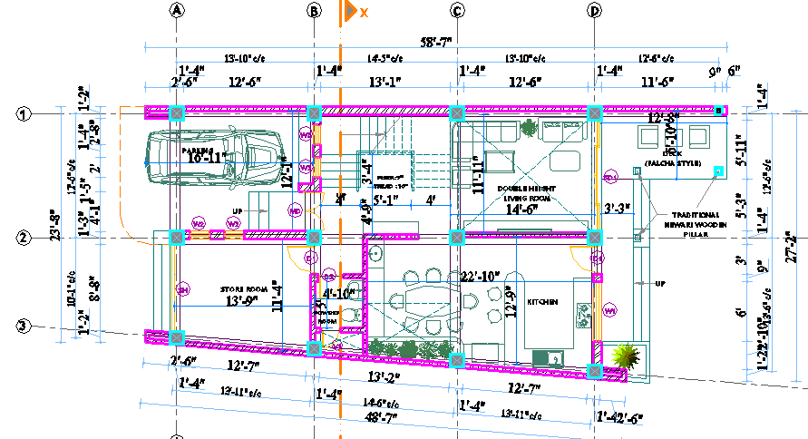
Figure 2-1GroundFloor Plan of the Building
Table 2-1: Building Description
General features
Building Type | Residential Building
Location | Bhaktapur Municipality
Ground Floor Area | 1214.34 . ft.
Architectural features
Number of storey | Five Storey
Floor Height | 9’0” for all floors
Total Height of the Building: | 45’0” up to top level from plinth level
Building Lateral Dimensions (Maximum ) | Along X: 48’-7”
Building Lateral Dimensions (Maximum ) | Along Y: 27’-2”
Wall and Partition | Brick Masonry in Concrete Mortar outside walls as well as partition walls
Structural features
Structural System | Special Moment Resisting RCC Frame Structure
Foundation Type | Isolated Footing, Strap Beam & Combine footing
Columns | Rectangular RCC Sections
Beams | Rectangular RCC Sections
Slab | RCC Sections
Geotechnical Features
Soil Test | Available
Soil Type (assumed) | Type II (Soft Soil)
Seismic Zone considered: | D (as per NBC 105:2025)
Allowable bearing capacity assumed | 120 KN/m²
Material
Grade of concrete: | M20 for column &beam, M20 for slab, staircase, intermediate beam, fascia beam and footings.
Grade of steel: | Fe 500
Unit weight of concrete | 20 KN/m³
Unit weight of the masonry wall | 19.2 KN/ m³
Unit weight of cement sand plaster | 20.4 KN/ m³
Young’s Modulus of Elasticity | 5000 √f_{ck}
Poisson’s Ratio | 0.20 for concrete
Poisson’s Ratio | 0.30 for rebar

NUMERICAL MODELING
A three-dimensional finite element model of the whole structural system is created in SAP 2000. The structural system is considered as a Special Moment Resisting Frame structure. Main components to be modeled are: Beams, Columns & Slabs. Beams and columns are modeled as frame elements while slabs are modeled as four-nodded shell elements. The support condition at the base is idealized as a fixed support and hence any moment release at the base of columns is neglected. The moment release at the beam/column joints is also neglected.
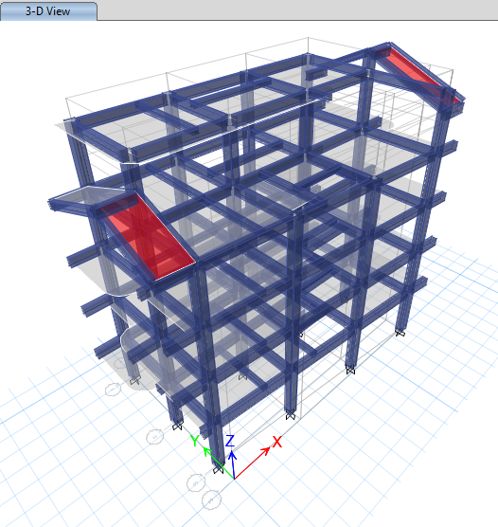
Figure 3-1: Three-Dimensional view of Model created in Etabs
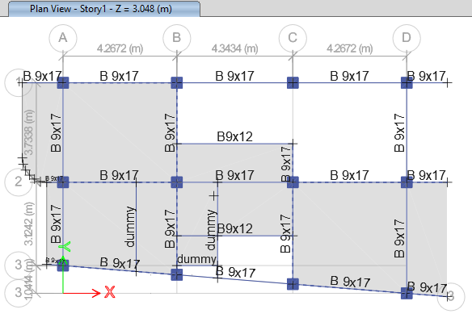
Figure 3-2: First Floor Plan of Model created in Etabs
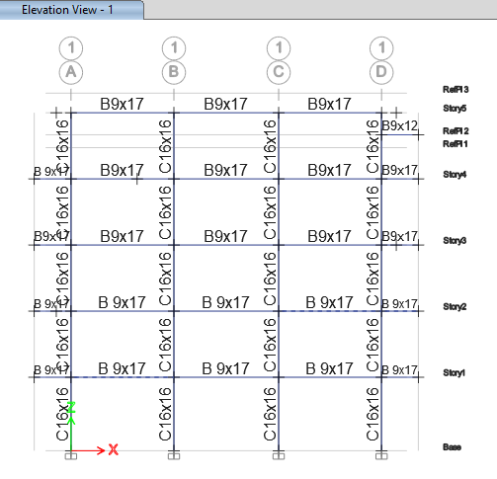
Figure 3-3: Elevation along grid 2-2 of Model created in Etabs

STRUCTURAL ANALYSIS
For the purpose of structural analysis IS Codes are followed for loadings, and Nepal Building Code is considered for load combinations and for other analysis procedures are followed.

Load Cases Considered
Following loads have been considered in the analysis of the building as per NBC 105:2025.
1. Dead Load (DL)
2. Live load (LL)
3. Earthquake load in +ve X-direction (EQ_{X})
4. Earthquake load in –ve X-direction (-EQ_{X})
5. Earthquake load in +ve Y-direction (EQ_{Y})
6. Earthquake load in –ve Y-direction (-EQ_{Y})

Load Combination
Following load combinations have been adopted as per NBC 105:2025 for Static Analysis.

For Parallel System

1.2DL+1.5LL
DL+λLL ± EQ_{(x,y)}
0.9DL±EQ_{(x,y)}
Where,
λ = 0.6 for storage facilities.
= 0.3 for other usage
DL= Dead load
LL = Imposed (Live) load
EQ_{(x,y)} = Earthquake load (Along X and Y direction)

For Non-Parallel System

1.2DL+1.5LL
DL+λLL ± (EQ_{x} ± 0.3EQ_{y})
DL+λLL ± (EQ_{y} ± 0.3EQ_{x})
0.9DL± (EQ_{x} ± 0.3EQ_{y})
0.9DL± (EQ_{y} ± 0.3EQ_{x})
Where,
λ = 0.6 for storage facilities.
= 0.3 for other usage
DL= Dead load
LL = Imposed (Live) load
EQ_{(x,y)} = Earthquake load (Along X and Y direction)

Dead Loads
Dead loads are assumed to be produced by slab, beams, columns, walls, parapet walls, plasters and mortars and floor finish. The weight of building materials are taken as per IS 875 (Part 1-1987).
Table 4-1: Dead Loads
Specific weight of materials [Ref: IS: 875(Part 1)-1987)]
Materials | Unit weight(γ)
Reinforced Concrete | 25.00 kN/m³
Brick Masonry | 19.20 kN/m³
Floor Finishing (Screeding & punning) | 23.00 kN/m³
Cement Sand Plaster | 20.40 kN/m³

Wall Loads
The wall loads are applied to the associated beams as uniformly distributed loads. Reduction for the openings is made wherever necessary.
UDL due to wall = height * thickness * sp. Weight
Table 4-2: Wall loads Applied to the Frames

S.N. | Wall t(mm) | Storey Ht(m) | Beam d(mm) | Ht. of Wall (m) | kN/m | Opening | kN/m | Adopt UDL | Remarks
1 | 230 | 2.8448 | 355.6 | 2.4892 | 11.450 | 0% | 11.450 | 12. | 230mm wall below Beam
1 | 230 | 2.8448 | 355.6 | 2.4892 | 11.450 | 20% | 9.160 | 10 | 230mm wall below Beam
1 | 230 | 2.8448 | 355.6 | 2.4892 | 11.450 | 30% | 8.015 | 9 | 230mm wall below Beam
2 | 127 | 2.8448 | 355.6 | 2.4892 | 6.323 | 0% | 6.323 | 7 | 127 mm wall below Beam
2 | 127 | 2.8448 | 355.6 | 2.4892 | 6.323 | 20% | 5.058 | 6 | 127 mm wall below Beam
2 | 127 | 2.8448 | 355.6 | 2.4892 | 6.323 | 30% | 4.426 | 5 | 127 mm wall below Beam

Live Loads
Live loads are applied on floor slabs on the basis of usage of rooms, as specified in IS 875 part II.
Table 4-3: Live Loads
Rooms | 2.0 kN/m²
Toilet/ Bathrooms | 2.0 kN/m²
Staircase/Balcony | 3.0 kN/m²
Roof | 1.5 kN/m²

loads on super-structure
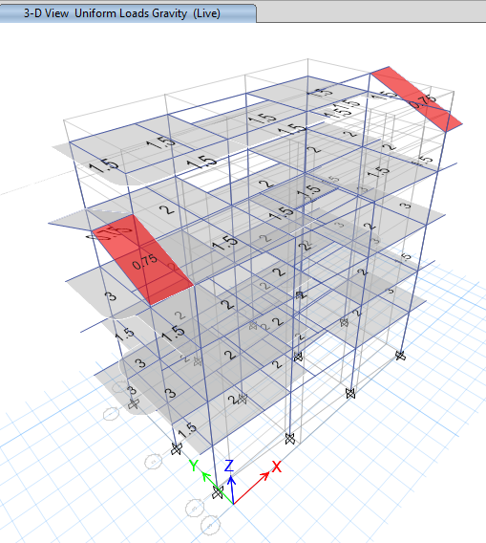
Figure 4-1: Area uniform load to frame (Live) (kN/m²)
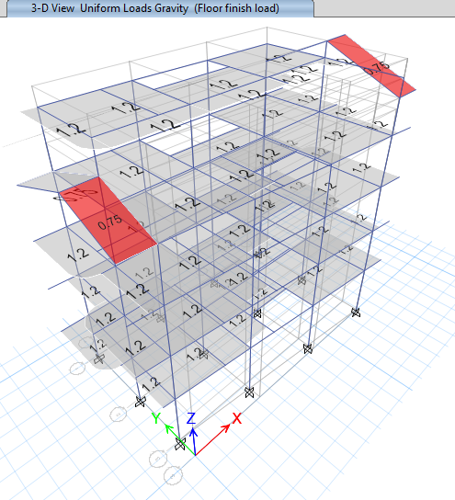
Figure 4-2: Area uniform load to frame (Floor finish) (kN/m²)
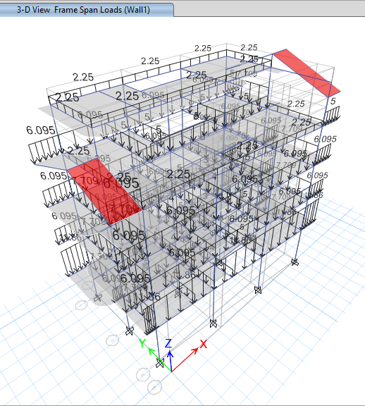
Figure 4-3: Wall loads on beams (kN/m)

Seismic Loads (Earthquake loads)

Seismic Coefficient Method
Sesmic Coefficient As Per NBC 105:2025
Height of Building= |  |  |  |  |  |  | 13.7153307 | 45
SesmicZoining Factor (Z)= |  |  |  |  |  |  | 0.35
Important Factor= |  |  |  |  |  |  | 1
Soil Type |  |  |  |  |  |  | D
Period of vibration:
For Reinforced Moment Resisting Frame kt = |  |  |  |  |  |  | 0.075
 |  |  |  |  |  |  | 0.53452248
T1 =1.25* kt H ¾ |  |  |  |  |  |  | 0.6681531
Lower Period of the flat part of the Spectrum Ta= |  |  |  |  |  |  | 0.5
Upper period of the flat part of the Spectrum Tc = |  |  |  |  |  |  | 2 | 2.670383
Peak Spectral Acceleration Normalized by PGAo α = |  |  |  |  |  |  | 2.25 | 2.25
Coefficient to control the decending branch of Spectrum K= |  |  |  |  |  |  | 0.8 | 52.25472
Calculation of Spectral Shape Factor, Ch(T) |  |  |  |  |  |  | 2.25
Since,
'=𝛼𝑖𝑓𝑇𝑎≤𝑇≤𝑇𝑐
 |  |  | Ch(T) | = |  |  | 2.25
Elastic site spectra for horizontal loading (Clause 4.1.1 NBC 105:2025)
 |  | C (T) =Ch(T) Z I |  | = |  |  | 0.7875
elastic site spectra for Serviceability Limit State(Clause 4.2 NBC 105:2025)
mm |  | Cs (T) = 0.20 C (T) |  | = |  |  | 0.1575
horizontal base shear coefficient for Equivalent Static Method :
Ref. Table 5.2 NBC 105:2020
Ductility Factor for ULS (Ru)= |  |  |  | = |  |  | 4
Over-strength factor for ULS (Ωu)= |  |  |  | = |  |  | 1.5
Over-strength factor for SLS (Ωs)= |  |  |  | = |  |  | 1.25
Ultimate limit state
horizontal base shear coefficient at the ULS State (Clause 6.1(1) NBC 105:2025)
 |  | Cd(𝑇1)=C(𝑇1)/(Rμ x Ωu) |  |  | = |  | 0.13125
Serviceability limit state,
horizontal base shear coefficient at the SLS State (Clause 6.1(2) NBC 105:2025)
 |  | Cd(𝑇1)=Cs(𝑇1)/Ωs |  |  | = |  | 0.126
exponent related to the structural period (k) |  |  |  |  | = |  | 1.08407655
Displacement Criteria for Eqivalent Static Method:
Alloable ratio ULS |  |  | 0.025 |  | = |  | 0.025
Allowable Displacement ULS |  |  | =0.025*H/Rμ |  | = |  | 85.7208168 | mm
Alloable ratio SLS |  |  | 0.006 |  | = |  | 0.006
Allowable Displacement SLS |  |  | =0.006*H/Rs |  | = |  | 82.2919842
DriftCriteria for Eqivalent Static Method:
Story drift from ETABS ULS |  |  |  |  | = |  | 0.0057 | OK
Allowable drift ULS |  |  | =0.025/Rμ |  | = |  | 0.00625
Story drift from ETABS SLS |  |  |  |  | = |  | 0.0055 | OK
Allowable Drift SLS |  |  | =0.006/Rs |  | = |  | 0.006

Dynamic Analysis
Response Spectrum Method
The dynamic analysis was performed by Response spectrum Method using a design spectrum offered by NBC 105: 2025.
For the purpose of analysis, seismic forces are applied in the model of the building in Etabs 2019.1.0. Hence, the manual calculations of seismic weight, base shear and the seismic forces have not been shown. However, the Etabs 2019.1.0 outputs for the Seismic Weight, Base Shear are shown.
Cracked Section Analysis
The effective stiffness of Different section shall be taken as: (NBC 105:2025 cl.3.4 Table 3-1)
S No. | Component | Flexural Stiffness
 |  | Ultimate | Service
1 | Beam | 0.35 Ec Ig | 0.7 Ec Ig
2 | Column | 0.7 Ec Ig | 0.9 Ec Ig
3 | Wall-cracked | 0.5 Ec Ig | 0.7 Ec Ig
4 | Wall-uncracked | 0.6 Ec Ig | 0.9 Ec Ig
5 | Masonary Wall | 0.45 Ec Ig | 0.6 Ec Ig
6 | Flat Slabs | 0.45 Ec Ig | 0.5 Ec Ig

Auto seismic user coefficient Table
Name | Is Auto Load | Ecc Ratio | Top Story | Bottom Story | C | K | Weight Used  kN | Base Shear  kN
Eq-X(SLS) | No | 0.05 | Story5 | Base | 0.126 | 1.08
Eq-X(SLS)(1/3) | Yes | 0.05 | Story5 | Base | 0.126 | 1.08 | 6060.3898 | 763.6091
Eq-X(SLS)(2/3) | Yes | 0.05 | Story5 | Base | 0.126 | 1.08 | 6060.3898 | 763.6091
Eq-X(SLS)(3/3) | Yes | 0.05 | Story5 | Base | 0.126 | 1.08 | 6060.3898 | 763.6091
Eq-X(ULS) | No | 0.05 | Story5 | Base | 0.131 | 1.08
Eq-X(ULS)(1/3) | Yes | 0.05 | Story5 | Base | 0.131 | 1.08 | 6060.3898 | 793.9111
Eq-X(ULS)(2/3) | Yes | 0.05 | Story5 | Base | 0.131 | 1.08 | 6060.3898 | 793.9111
Eq-X(ULS)(3/3) | Yes | 0.05 | Story5 | Base | 0.131 | 1.08 | 6060.3898 | 793.9111
Eq-Y(SLS) | No | 0.05 | Story5 | Base | 0.126 | 1.08
Eq-Y(SLS)(1/3) | Yes | 0.05 | Story5 | Base | 0.126 | 1.08 | 6060.3898 | 763.6091
Eq-Y(SLS)(2/3) | Yes | 0.05 | Story5 | Base | 0.126 | 1.08 | 6060.3898 | 763.6091
Eq-Y(SLS)(3/3) | Yes | 0.05 | Story5 | Base | 0.126 | 1.08 | 6060.3898 | 763.6091
Eq-Y(ULS) | No | 0.05 | Story5 | Base | 0.131 | 1.08
Eq-Y(ULS)(1/3) | Yes | 0.05 | Story5 | Base | 0.131 | 1.08 | 6060.3898 | 793.9111
Eq-Y(ULS)(2/3) | Yes | 0.05 | Story5 | Base | 0.131 | 1.08 | 6060.3898 | 793.9111
Eq-Y(ULS)(3/3) | Yes | 0.05 | Story5 | Base | 0.131 | 1.08 | 6060.3898 | 793.9111

Modal Analysis and Modal Mass Participation
No of modes considered for Modal Analysis:50
Mass Participation: More than 90% in both directions(NBC 105:2025 cl.7.3)

Table 4-4: Modal Mass Participation Ratio
Case | Mode | Period  sec | UX | UY | UZ | SumUX | SumUY | SumUZ
Modal | 1 | 0.933 | 0.5606 | 0.1501 | 0 | 0.5606 | 0.1501 | 0
Modal | 2 | 0.909 | 0.2193 | 0.5843 | 0 | 0.7799 | 0.7344 | 0
Modal | 3 | 0.773 | 0.0468 | 0.1017 | 0 | 0.8267 | 0.8361 | 0
Modal | 4 | 0.307 | 0.1111 | 0.0001 | 0 | 0.9378 | 0.8361 | 0
Modal | 5 | 0.286 | 0.0007 | 0.1008 | 0 | 0.9385 | 0.937 | 0
Modal | 6 | 0.249 | 0.0019 | 0.0146 | 0 | 0.9404 | 0.9516 | 0
Modal | 7 | 0.17 | 0.0401 | 5.414E-07 | 0 | 0.9805 | 0.9516 | 0
Modal | 8 | 0.153 | 1.145E-05 | 0.0328 | 0 | 0.9805 | 0.9844 | 0
Modal | 9 | 0.136 | 1.05E-05 | 0.0027 | 0 | 0.9805 | 0.9871 | 0
Modal | 10 | 0.112 | 0.0162 | 1.615E-05 | 0 | 0.9967 | 0.9871 | 0
Modal | 11 | 0.105 | 1.387E-05 | 0.0097 | 0 | 0.9967 | 0.9967 | 0
Modal | 12 | 0.098 | 5.084E-07 | 0.0002 | 0 | 0.9967 | 0.9969 | 0

Design Eccentricity
Esi= CM-CR
where,
Edi=Design Eccentricity, Esi= Static Eccentricity= Distance e Between CM and CR
CM= Center of Mass, CR= Center of Rigidity
Bi = Dimension of Building along the direction considered
Building Dimension Along X (Bx), for first floor & typical floor= 15.93m
Building Dimension Along Y for first floor & typical floor(By=8.46m
Building Dimension Along X for top floor (Bx)=11.81 |  |  |  | m
Building Dimension Along Y top floor (By)=8.46 |  |  |  | m

Table 4-5: Design Eccentricity
 |  |  |  |  |  |  |  |  |  | Check
Story | Diaphragm | XCCM | YCCM | XCR | YCR | ex | ey | Lx | Ly | x | y
 |  | m | m | m | m |  |  |  |  | x | y
Story5 | D1 | 6.61 | 5.61 | 6.05 | 4.38 | 0.56 | 1.23 | 15.93 | 8.10 | 0.035 | 0.152
Story4 | D1 | 6.96 | 5.07 | 6.16 | 4.63 | 0.80 | 0.43 | 15.93 | 8.10 | 0.050 | 0.053
Story3 | D1 | 6.81 | 4.76 | 6.21 | 4.36 | 0.60 | 0.40 | 15.93 | 8.10 | 0.038 | 0.049
Story2 | D1 | 6.76 | 4.64 | 6.23 | 4.29 | 0.53 | 0.35 | 15.93 | 8.10 | 0.033 | 0.043
Story1 | D1 | 6.52 | 4.42 | 6.31 | 4.19 | 0.21 | 0.24 | 15.93 | 8.10 | 0.013 | 0.029
Hence, Building eccentricity has been found within 10%. Therefore, dynamic analysis is not mandatory.

Check For Torsional Irregularity
Torsion Irregularity is checked as per (NBC 105:2025
cl.5.5.2.1)
If Δ_{max}> 1.5 Δ_{min}, building is considered to have torsional irregularity.
Where,
Δ_{max} = Maximum displacement of the Storey under the action of Earthquake load
Δ_{min} = Minimum displacement of the Storey under the action of Earthquake load.
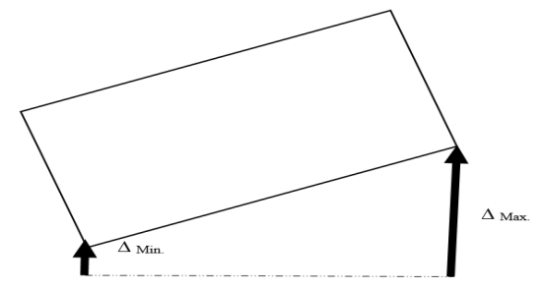
Table 4-6 Ratio of Maximum to Average Storey Displacements for different Storey
TABLE: Story Max Over Avg Displacement
Story | Output Case | Step Type | Step Number | Direction | Maximum | Average | Ratio
 |  |  |  |  | mm | mm | Ratio
Story5 | Modal | Mode | 1 | X | 0.06 | 0.06 | 1.13
Story5 | Eq-X(SLS) | Step By Step | 1 | X | 46.87 | 45.77 | 1.02
Story4 | Eq-X(SLS) | Step By Step | 1 | X | 41.90 | 39.60 | 1.06
Story3 | Eq-X(SLS) | Step By Step | 1 | X | 33.45 | 31.67 | 1.06
Story2 | Eq-X(SLS) | Step By Step | 1 | X | 22.23 | 21.08 | 1.06
Story1 | Eq-X(SLS) | Step By Step | 1 | X | 9.82 | 9.32 | 1.05
Story5 | Eq-X(SLS) | Step By Step | 2 | X | 48.32 | 46.49 | 1.04
Story4 | Eq-X(SLS) | Step By Step | 2 | X | 43.29 | 39.51 | 1.10
Story3 | Eq-X(SLS) | Step By Step | 2 | X | 34.60 | 31.60 | 1.10
Story2 | Eq-X(SLS) | Step By Step | 2 | X | 23.01 | 21.03 | 1.09
Story1 | Eq-X(SLS) | Step By Step | 2 | X | 10.18 | 9.30 | 1.09
Story5 | Eq-X(SLS) | Step By Step | 3 | X | 45.43 | 45.06 | 1.01
Story4 | Eq-X(SLS) | Step By Step | 3 | X | 40.52 | 39.69 | 1.02
Story3 | Eq-X(SLS) | Step By Step | 3 | X | 32.30 | 31.74 | 1.02
Story2 | Eq-X(SLS) | Step By Step | 3 | X | 21.45 | 21.12 | 1.02
Story1 | Eq-X(SLS) | Step By Step | 3 | X | 9.47 | 9.34 | 1.01
Story5 | Eq-X(ULS) | Step By Step | 1 | X | 48.74 | 47.59 | 1.02
Story4 | Eq-X(ULS) | Step By Step | 1 | X | 43.56 | 41.17 | 1.06
Story3 | Eq-X(ULS) | Step By Step | 1 | X | 34.78 | 32.92 | 1.06
Story2 | Eq-X(ULS) | Step By Step | 1 | X | 23.11 | 21.91 | 1.06
Story1 | Eq-X(ULS) | Step By Step | 1 | X | 10.21 | 9.69 | 1.05
Story5 | Eq-X(ULS) | Step By Step | 2 | X | 50.23 | 48.33 | 1.04
Story4 | Eq-X(ULS) | Step By Step | 2 | X | 45.00 | 41.08 | 1.10
Story3 | Eq-X(ULS) | Step By Step | 2 | X | 35.97 | 32.85 | 1.10
Story2 | Eq-X(ULS) | Step By Step | 2 | X | 23.93 | 21.87 | 1.09
Story1 | Eq-X(ULS) | Step By Step | 2 | X | 10.58 | 9.67 | 1.09
Story5 | Eq-X(ULS) | Step By Step | 3 | X | 47.24 | 46.85 | 1.01
Story4 | Eq-X(ULS) | Step By Step | 3 | X | 42.13 | 41.26 | 1.02
Story3 | Eq-X(ULS) | Step By Step | 3 | X | 33.58 | 33.00 | 1.02
Story2 | Eq-X(ULS) | Step By Step | 3 | X | 22.30 | 21.96 | 1.02
Story1 | Eq-X(ULS) | Step By Step | 3 | X | 9.85 | 9.71 | 1.01
Story5 | Eq-Y(SLS) | Step By Step | 1 | Y | 46.10 | 40.76 | 1.13
Story4 | Eq-Y(SLS) | Step By Step | 1 | Y | 42.75 | 38.04 | 1.12
Story3 | Eq-Y(SLS) | Step By Step | 1 | Y | 34.57 | 30.97 | 1.12
Story2 | Eq-Y(SLS) | Step By Step | 1 | Y | 23.01 | 20.69 | 1.11
Story1 | Eq-Y(SLS) | Step By Step | 1 | Y | 10.04 | 9.13 | 1.10
Story5 | Eq-Y(SLS) | Step By Step | 2 | Y | 51.65 | 41.06 | 1.26
Story4 | Eq-Y(SLS) | Step By Step | 2 | Y | 47.97 | 38.28 | 1.25
Story3 | Eq-Y(SLS) | Step By Step | 2 | Y | 38.86 | 31.16 | 1.25
Story2 | Eq-Y(SLS) | Step By Step | 2 | Y | 25.92 | 20.82 | 1.25
Story1 | Eq-Y(SLS) | Step By Step | 2 | Y | 11.33 | 9.18 | 1.24
Story5 | Eq-Y(SLS) | Step By Step | 3 | Y | 40.54 | 40.47 | 1.00
Story4 | Eq-Y(SLS) | Step By Step | 3 | Y | 38.07 | 37.80 | 1.01
Story3 | Eq-Y(SLS) | Step By Step | 3 | Y | 31.29 | 30.78 | 1.02
Story2 | Eq-Y(SLS) | Step By Step | 3 | Y | 21.03 | 20.57 | 1.02
Story1 | Eq-Y(SLS) | Step By Step | 3 | Y | 9.43 | 9.09 | 1.04
Story5 | Eq-Y(ULS) | Step By Step | 1 | Y | 47.93 | 42.38 | 1.13
Story4 | Eq-Y(ULS) | Step By Step | 1 | Y | 44.45 | 39.55 | 1.12
Story3 | Eq-Y(ULS) | Step By Step | 1 | Y | 35.94 | 32.20 | 1.12
Story2 | Eq-Y(ULS) | Step By Step | 1 | Y | 23.93 | 21.51 | 1.11
Story1 | Eq-Y(ULS) | Step By Step | 1 | Y | 10.44 | 9.50 | 1.10
Story5 | Eq-Y(ULS) | Step By Step | 2 | Y | 53.70 | 42.69 | 1.26
Story4 | Eq-Y(ULS) | Step By Step | 2 | Y | 49.88 | 39.80 | 1.25
Story3 | Eq-Y(ULS) | Step By Step | 2 | Y | 40.40 | 32.40 | 1.25
Story2 | Eq-Y(ULS) | Step By Step | 2 | Y | 26.94 | 21.64 | 1.25
Story1 | Eq-Y(ULS) | Step By Step | 2 | Y | 11.78 | 9.54 | 1.24
Story5 | Eq-Y(ULS) | Step By Step | 3 | Y | 42.15 | 42.08 | 1.00
Story4 | Eq-Y(ULS) | Step By Step | 3 | Y | 39.58 | 39.30 | 1.01
Story3 | Eq-Y(ULS) | Step By Step | 3 | Y | 32.53 | 32.01 | 1.02
Story2 | Eq-Y(ULS) | Step By Step | 3 | Y | 21.86 | 21.39 | 1.02
Story1 | Eq-Y(ULS) | Step By Step | 3 | Y | 9.80 | 9.45 | 1.04

The table shows that the ratio Δ_{max}/Δ_{min} has been limited to limiting value of 1.5, hence indicating that Torsional Irregularities does not exist in building.

Analysis &Design Parameters
Followings factors are considered for earthquake resistant design of the building.

Table 4-7: Analysis & Design Parameters
Method adopted for design |  | Seismic Coefficient method
Design code |  | NBC 105 :2025
Height of building |  | 14.05 m
Zone factor(Z) |  | 0.35
Soil Type |  | Type D
Importance factor(I) |  | 1
Ductility factor (Rμ) |  | 4
Over strength factor(Ωu) |  | 1.5
Over-strength factor for SLS (Ωs) |  | 1.25
Mass participation in dynamic analysis |  | Above 90 % along both directions
Fundamental Time Period (T) | Along X (sec) | 0.54282181
Fundamental Time Period (T) | Along Y (sec) | 0.54282181
Seismic Weight (W) (kN) |  | 6060.3898
Lower period of flat part (Ta) (sec) |  | 0.5
Upper period of flat part (Tc) (sec) |  | 2
Spectral shape factor (Ch(t)) |  | 2.25
Elastic site spectra ULS (C(t)) |  | 0.7875
Elastic site spectra SLS (C(t)) |  | 0.1575
Horizontal base shear coefficient ULS |  | 0.13125
Horizontal base shear coefficient SLS |  | 0.126
Exponent Related to structural period K |  | 1.08
Base shear from seismic coefficient method along –x (KN) |  | 793.9111
Base shear from seismic coefficient method along -y (KN) |  | 793.9111

Story Drift Calculations
Table 4-8: Story Drift against Earthquake Loads
Story | Output Case | Step Type | Step Number | Direction | Max Drift | Avg Drift | Ratio
 |  |  |  |  | mm | mm | Ratio
Story5 | Modal | Mode | 1 | X | 0.01 | 0.01 | 1.12
Story5 | Eq-X(SLS) | Step By Step | 1 | X | 5.69 | 5.32 | 1.07
Story5 | Eq-X(SLS) | Step By Step | 2 | X | 5.58 | 5.26 | 1.06
Story5 | Eq-X(SLS) | Step By Step | 3 | X | 5.80 | 5.36 | 1.08
Story5 | Eq-X(ULS) | Step By Step | 1 | X | 5.92 | 5.53 | 1.07
Story5 | Eq-X(ULS) | Step By Step | 2 | X | 5.80 | 5.47 | 1.06
Story5 | Eq-X(ULS) | Step By Step | 3 | X | 6.03 | 5.57 | 1.08
Story5 | Eq-Y(SLS) | Step By Step | 1 | Y | 3.40 | 2.75 | 1.24
Story5 | Eq-Y(SLS) | Step By Step | 2 | Y | 3.74 | 2.80 | 1.33
Story5 | Eq-Y(SLS) | Step By Step | 3 | Y | 3.06 | 2.70 | 1.14
Story5 | Eq-Y(ULS) | Step By Step | 1 | Y | 3.54 | 2.86 | 1.24
Story5 | Eq-Y(ULS) | Step By Step | 2 | Y | 3.89 | 2.92 | 1.33
Story5 | Eq-Y(ULS) | Step By Step | 3 | Y | 3.18 | 2.80 | 1.14
Story4 | Eq-X(SLS) | Step By Step | 1 | X | 8.45 | 7.93 | 1.07
Story4 | Eq-X(SLS) | Step By Step | 2 | X | 8.69 | 7.91 | 1.10
Story4 | Eq-X(SLS) | Step By Step | 3 | X | 8.22 | 7.95 | 1.03
Story4 | Eq-X(ULS) | Step By Step | 1 | X | 8.79 | 8.24 | 1.07
Story4 | Eq-X(ULS) | Step By Step | 2 | X | 9.03 | 8.22 | 1.10
Story4 | Eq-X(ULS) | Step By Step | 3 | X | 8.55 | 8.26 | 1.03
Story4 | Eq-Y(SLS) | Step By Step | 1 | Y | 8.59 | 7.11 | 1.21
Story4 | Eq-Y(SLS) | Step By Step | 2 | Y | 9.72 | 7.16 | 1.36
Story4 | Eq-Y(SLS) | Step By Step | 3 | Y | 7.46 | 7.06 | 1.06
Story4 | Eq-Y(ULS) | Step By Step | 1 | Y | 8.93 | 7.39 | 1.21
Story4 | Eq-Y(ULS) | Step By Step | 2 | Y | 10.11 | 7.45 | 1.36
Story4 | Eq-Y(ULS) | Step By Step | 3 | Y | 7.75 | 7.34 | 1.06
Story3 | Eq-X(SLS) | Step By Step | 1 | X | 11.22 | 10.58 | 1.06
Story3 | Eq-X(SLS) | Step By Step | 2 | X | 11.59 | 10.55 | 1.10
Story3 | Eq-X(SLS) | Step By Step | 3 | X | 10.85 | 10.61 | 1.02
Story3 | Eq-X(ULS) | Step By Step | 1 | X | 11.67 | 11.00 | 1.06
Story3 | Eq-X(ULS) | Step By Step | 2 | X | 12.05 | 10.97 | 1.10
Story3 | Eq-X(ULS) | Step By Step | 3 | X | 11.29 | 11.03 | 1.02
Story3 | Eq-Y(SLS) | Step By Step | 1 | Y | 11.93 | 10.30 | 1.16
Story3 | Eq-Y(SLS) | Step By Step | 2 | Y | 13.63 | 10.36 | 1.32
Story3 | Eq-Y(SLS) | Step By Step | 3 | Y | 10.34 | 10.24 | 1.01
Story3 | Eq-Y(ULS) | Step By Step | 1 | Y | 12.40 | 10.71 | 1.16
Story3 | Eq-Y(ULS) | Step By Step | 2 | Y | 14.17 | 10.78 | 1.32
Story3 | Eq-Y(ULS) | Step By Step | 3 | Y | 10.76 | 10.64 | 1.01
Story2 | Eq-X(SLS) | Step By Step | 1 | X | 12.43 | 11.76 | 1.06
Story2 | Eq-X(SLS) | Step By Step | 2 | X | 12.86 | 11.73 | 1.10
Story2 | Eq-X(SLS) | Step By Step | 3 | X | 12.00 | 11.79 | 1.02
Story2 | Eq-X(ULS) | Step By Step | 1 | X | 12.92 | 12.22 | 1.06
Story2 | Eq-X(ULS) | Step By Step | 2 | X | 13.37 | 12.19 | 1.10
Story2 | Eq-X(ULS) | Step By Step | 3 | X | 12.47 | 12.26 | 1.02
Story2 | Eq-Y(SLS) | Step By Step | 1 | Y | 13.32 | 11.58 | 1.15
Story2 | Eq-Y(SLS) | Step By Step | 2 | Y | 15.30 | 11.66 | 1.31
Story2 | Eq-Y(SLS) | Step By Step | 3 | Y | 11.65 | 11.43 | 1.02
Story2 | Eq-Y(ULS) | Step By Step | 1 | Y | 13.85 | 12.04 | 1.15
Story2 | Eq-Y(ULS) | Step By Step | 2 | Y | 15.91 | 12.12 | 1.31
Story2 | Eq-Y(ULS) | Step By Step | 3 | Y | 12.11 | 11.89 | 1.02
Story1 | Eq-X(SLS) | Step By Step | 1 | X | 9.82 | 9.32 | 1.05
Story1 | Eq-X(SLS) | Step By Step | 2 | X | 10.18 | 9.30 | 1.09
Story1 | Eq-X(SLS) | Step By Step | 3 | X | 9.47 | 9.34 | 1.01
Story1 | Eq-X(ULS) | Step By Step | 1 | X | 10.21 | 9.69 | 1.05
Story1 | Eq-X(ULS) | Step By Step | 2 | X | 10.58 | 9.67 | 1.09
Story1 | Eq-X(ULS) | Step By Step | 3 | X | 9.85 | 9.71 | 1.01
Story1 | Eq-Y(SLS) | Step By Step | 1 | Y | 10.04 | 9.13 | 1.10
Story1 | Eq-Y(SLS) | Step By Step | 2 | Y | 11.33 | 9.18 | 1.24
Story1 | Eq-Y(SLS) | Step By Step | 3 | Y | 9.43 | 9.09 | 1.04
Story1 | Eq-Y(ULS) | Step By Step | 1 | Y | 10.44 | 9.50 | 1.10
Story1 | Eq-Y(ULS) | Step By Step | 2 | Y | 11.78 | 9.54 | 1.24
Story1 | Eq-Y(ULS) | Step By Step | 3 | Y | 9.80 | 9.45 | 1.04

It is seen that the max drift ratios are:

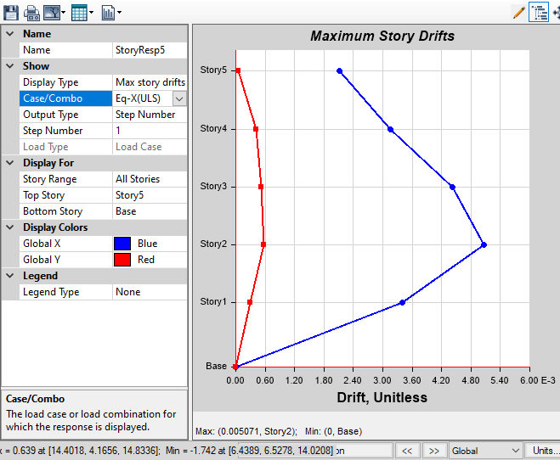
Maximum storey drift along x-direction @EqxUL

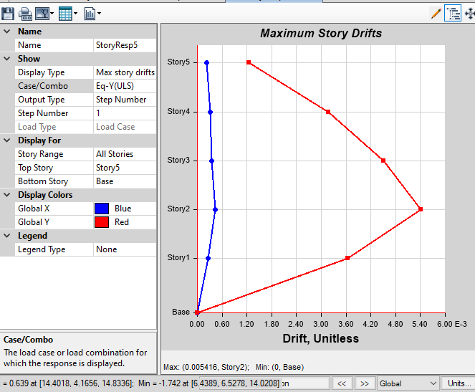
Maximum storey drift along Y-direction @EqyUL

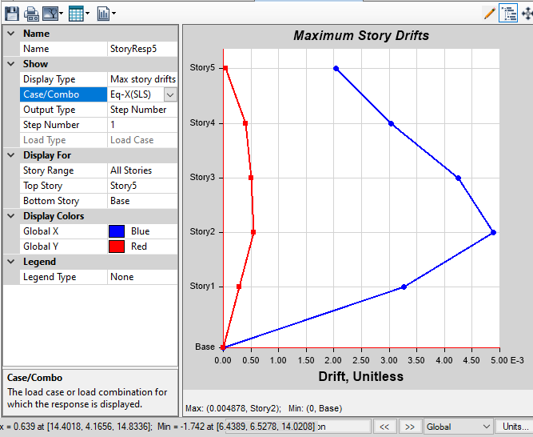
Maximum storey drift along x-direction @EqxSL
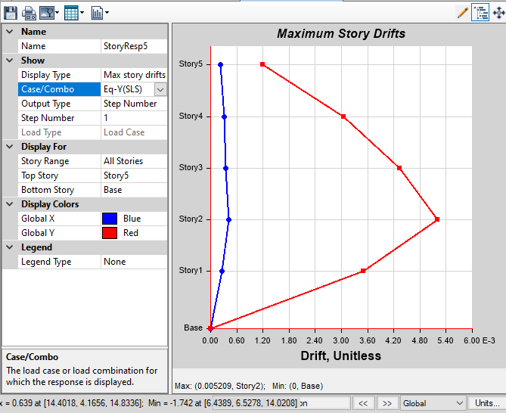
Maximum storey drift along Y-direction @EqySL
At Ultimate limit state:
-At cracked section:
Maximum drift ratio at cracked section 0.0025 (NBC 105:2025 cl.5.5.3)

At Serviceability limit state:
-At cracked section:
Maximum drift ratio at cracked section 0.006
Hence, Drifts are within the safe limits (NBC 105:2025 cl.5.5.3)

Moments and Shear Forces in Frames
The moments and shear forces of the buildings were analyzed using the Etabs 2019. The analysis is used for identification of critical sections and to find out the design requirements so as to design various structural components. The sample moment diagrams and shear force diagram samples of the sections around these critical components, as extracted from SAP 2000 are as follows:
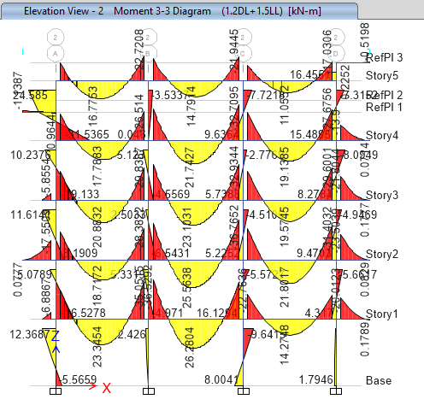
Figure 4-4: Sample Bending Moment Diagram for frames
Along Grid 2-2(1.2DL+1.5LL) Unit; kNm
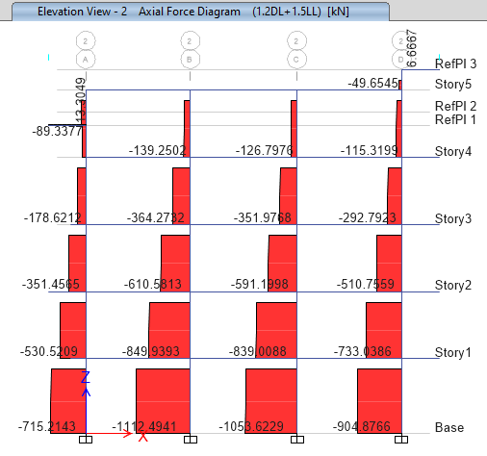
Figure 4-5: Sample Axial Force Diagram for frames
Along Grid 2-2(1.2DL+1.5LL) Unit; kN
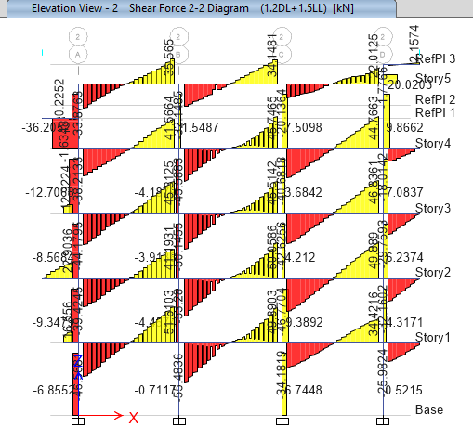
Figure 4-6: Sample Shear Diagram for frames
Along Grid 2-2(1.2DL+1.5LL) Unit; kNm

`DESIGN
The design of reinforced concrete structural members includes selection of material properties (grade of steel and concrete), shape and size of cross section, factor of safety and amount of steel required. The design of reinforced concrete members are carried out using limit state method as per IS 456: 2000. The limit state method is the modern and latest design methodology. This method evolved around 1970’s. Limit state method is based on the concept of multiple safety factors and attempts to provide adequate safety at the ultimate loads and adequate serviceability at service loads.
For the design of the members, IS 456:2000 and design aid SP 16 has been used. Footings have been checked for vertical loads and moments developed at the base due to dead load and live load only. Square footings have been adopted from seismic point of view that reversal stress may occur. And footing beams are provided for column at foundation for more rigidity of building and also need for the column located at boundary. Longitudinal reinforcement in beams and columns has been calculated based on critical load combination. Spacing of the shear reinforcement has been calculated as per the ductility criteria as defined in IS 13920 -2016.Some sample designs are shown later on in this report.;
Beams and columns have been designed using Etabs 2019.1.0. While slab, staircase are designed manually and some foundations are designed manually and some are using SAFEv16. Samples of manual design calculation of critical beam, column slab and footings are shown in this report in. The structural design of sections and reinforcements are presented in the drawing.

Design Summary
Column Design Summary

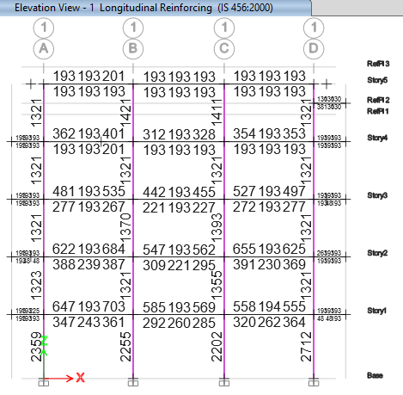

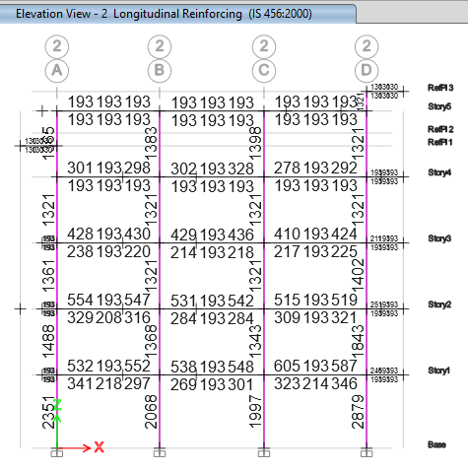
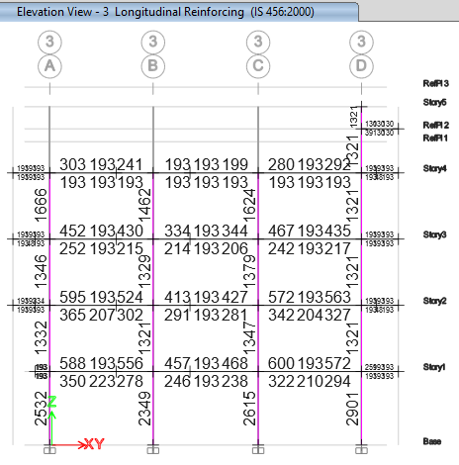
Table 0-1: Column Design Summary
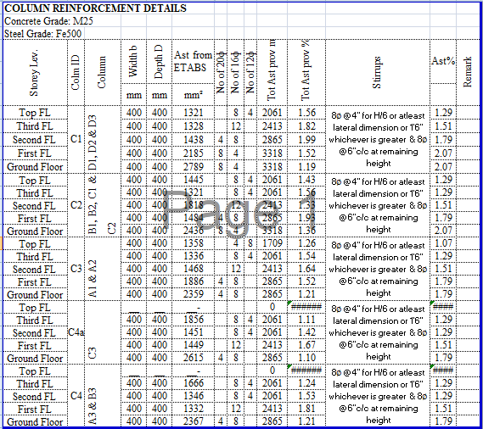
SPECIAL CONFINING REINFORCEMENT
 |  | The amount of special confining reinforcement required in columns shall be
calculated as follows:
 |  | L0 = 𝑚𝑎𝑥𝑖𝑚𝑢𝑚 (Dc; Lc⁄6 ; 450mm)…………………………4.3.1
Where,
 |  | Dc = Largest cross sectional dimension of column= |  |  |  |  |  |  |  |  | 350mm
lcl = Clear length of column= |  |  |  |  | 2843.645 |  |  |  |  | lc/6= | 473.9409 | mm
 |  | Hence, Provide Special confining bar up to 480mm on either side of column
 |  | The spacing of the confining reinforcement shall be as follows:
Spacing =Minimum(1⁄4 Bc; 6dc; 100mm )
Where,
 |  | Bc = Smallest cross sectional dimension of column= |  |  |  |  |  |  |  |  | 350mm
 |  | db = Diameter of smallest longitudinal bar of column= |  |  |  |  |  |  |  |  | 16
 |  |  |  |  |  |  |  |  |  |  | 6dc= | 96
Hence, Provide spacing of 100mm
in rectangular links:
𝐴
sh = Maximum of |  |  |  |  |  | {0.18Sv h fck/fy*(Ag/Acc-1) |  |  |  | = | 78 | mm^2
 |  |  |  | 0.05 Sv h fck/fy |  |  |  |  |  | = | 60 | mm^2
here,
 |  | h = longer dimension of rectangular link/hoop measured to its outer
face, which does not exceed 300 mm
 |  | Acc = area of confined concrete core in rectangular link/hoop
 |  | measured to its outer dimensions. Acc shall be measured as overall
 | core area, regardless of link/hoop arrangement.
Hence, provide bar dai of 8mm bar

Colm Shear Reinforcement
Design for shear reinforcement
shear reinforcement req Ast |  |  |  | = | 394.16 | mm^2/m
depth of beam |  |  |  | = | 350 | mm
width of beam |  |  |  | = | 350 | mm
Dia of stirrups |  |  |  | = | 8 | mm
no of leg stirrup provided = |  |  |  | = | 2 | nos
Area of leg stirrup provided = ast |  |  |  | = | 100.531 | mm^2
Spacing req = 1000*ast/Ast |  |  |  | = | 255.0512 | mm^2
Spacing provided |  |  |  | = | 150 | mm
Provided Shear Reinforcement |  |  |  | = | 1005.31 | mm^2
Beam Design Summary
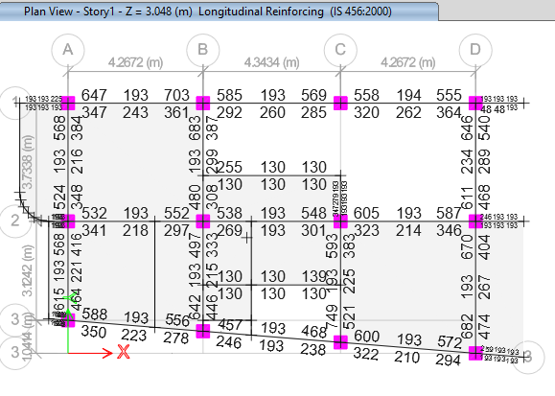
At First floor Level
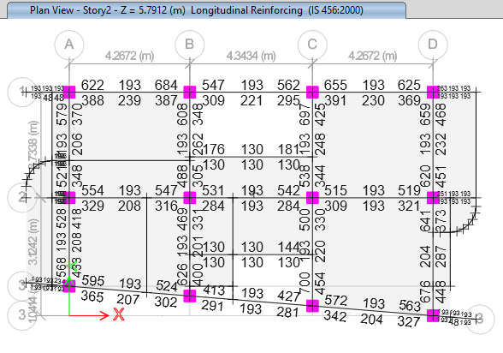
At Second floor level
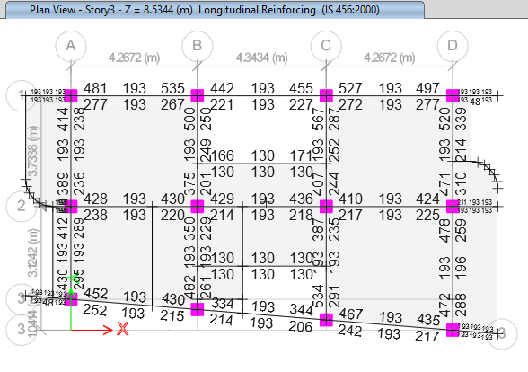
At Third floor Level
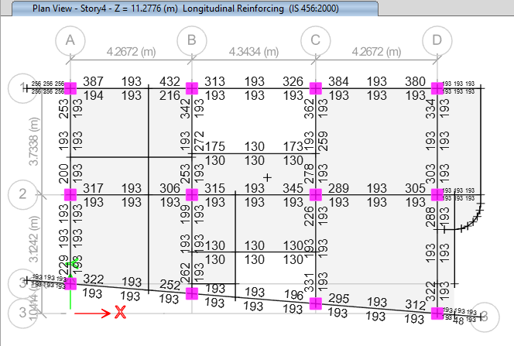
At Fourth floor Level
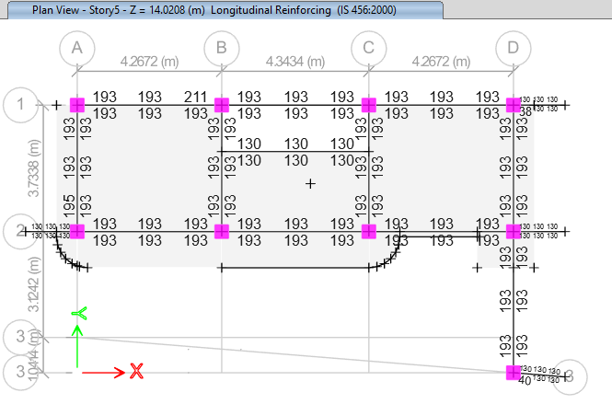
At Top floor Level

Table 0-2: Beam Design Summary
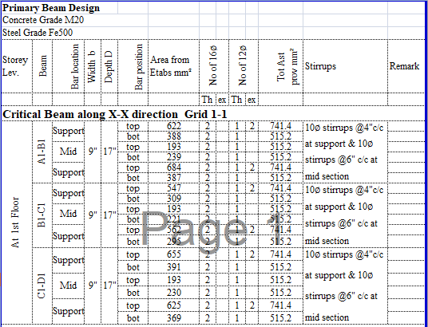
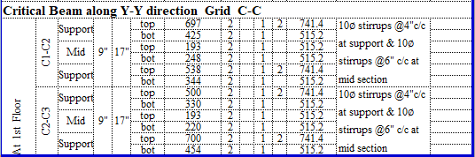

For more details refer structural drawing.

Design for shear reinforcement
shear reinforcement req Ast |  |  |  | = | 1275 | mm^2/m
depth of beam |  |  |  | = | 375 | mm
width of beam |  |  |  | = | 230 | mm
Dia of stirrups |  |  |  | = | 8 | mm
no of leg stirrup provided = |  |  |  | = | 0 | nos
Dia of stirrups |  |  |  | = | 10 | mm
no of leg stirrup provided = |  |  |  | = | 2 | nos
Area of leg stirrup provided = ast |  |  |  | = | 157.0796 | mm^2
Spacing req = 1000*ast/Ast |  |  |  | = | 123.1997 | mm^2
Spacing provided |  |  |  | = | 100 | mm
Provided Shear Reinforcement |  |  |  | = | 1570.796 | mm^2
Hence, 2L-10dia stirruos are provided.

Slab Design Summary
Depth of Slab: 5”
Reinforcement provide 8mm@6" c/c both ways with usual layouts/curtailments wherever required
For more details refer structural drawings.

Staircase Design Summary

Waist Slab Thickness: 5" Overall
Clear cover: 20 mm
Longitudinal reinforcement: 12 mm bars@ 6" c/c
Transverse Reinforcement: 8 mm bars @ 6"c/c
Size of landing beam:9" x 6"
Reinforcement in landing beam: 2-12 ϕ at top and bottom
With 8ϕ 2-legged stirrups @ 4" c/c
For more details refer structural drawing.

Foundation Design Summary

The foundation is designed as MAT Footing. The footing base is to be formed at 5’6” ' below ground level.

The footing is modeled as a thick plate. The position of columns is located and loads from superstructure are applied to it.
Soil Bearing Capacity (SBC) =120 kN/m²
The modulus of subgrade is computed using Bowles equation as follows
Modulus of Subgrade = 40xSBCxSafety Factor= 40x130x3 = 15600 kN/m³.
Concrete Grade= M20 (f_{ck}= 20 Mpa) for Mat
Reinforcement Steel Grade = Fe500 (f_{y} = 500 Mpa

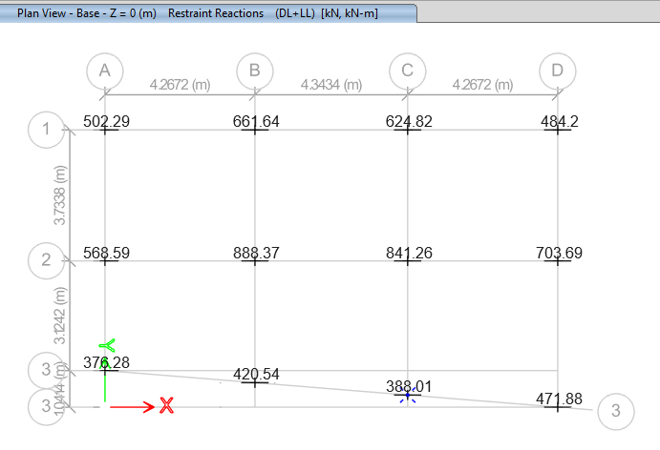
Base Reaction At Dl +LL
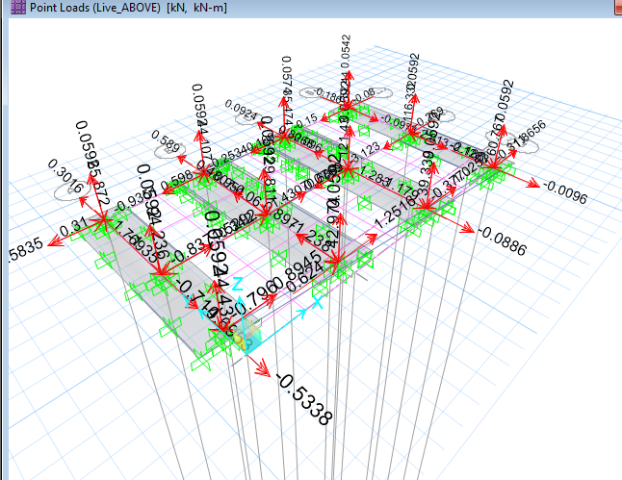
Footing Model in Safe
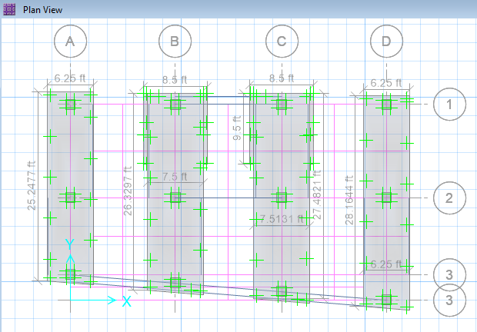
Footing Model in Safe
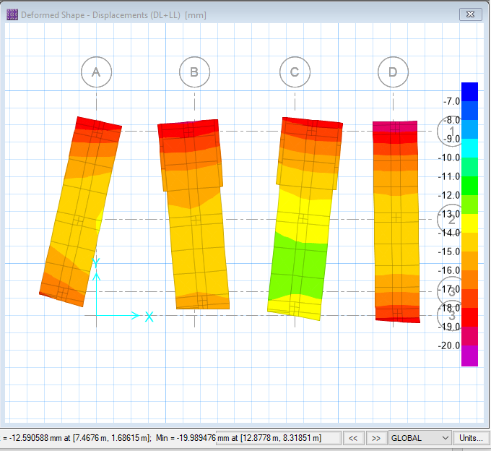

Footing displacement at DL+LL
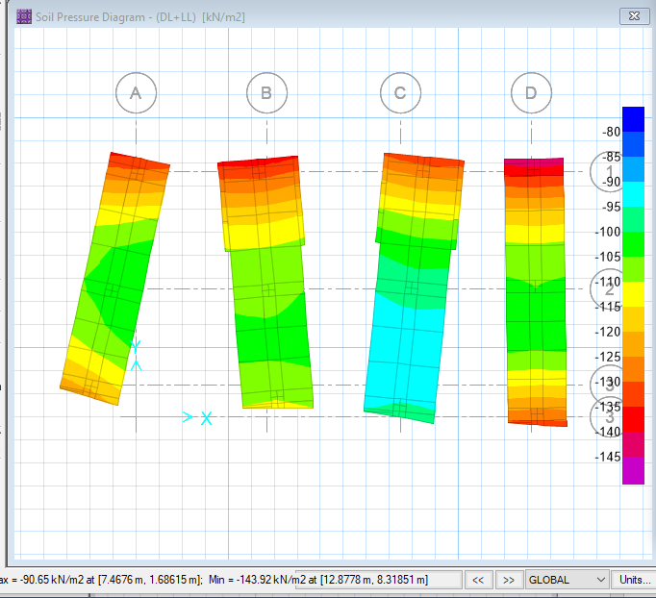
Soil Pressure at DL+LL
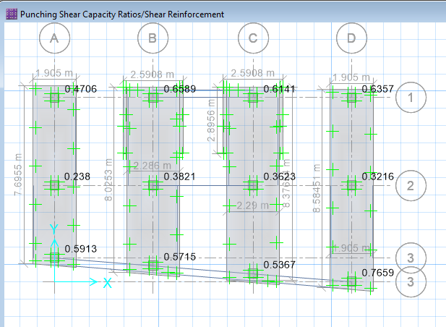
Punching Shear

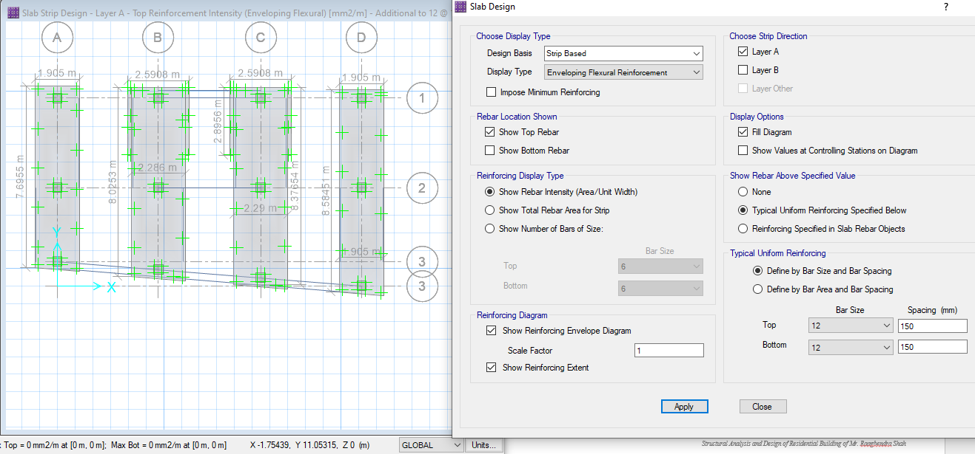

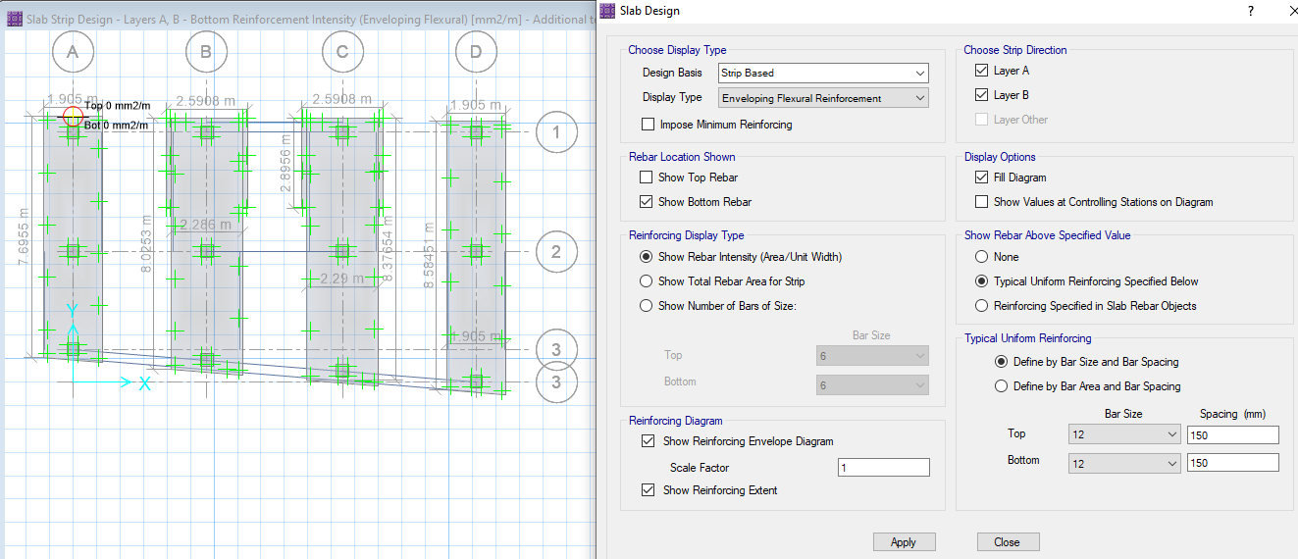

Slab Design of Footing

Combine Footing Design CF1
At C2-C3
Bearing Capacity = |  | 120 | KNm |  | S  col 1  col 2
 | Fy= | 500 |  |  |  |  |  |  |  |  | width of footing
 | Fck = | 20 |  |  |  |  |  |  |  |  | width of footing
 |  |  |  | col 3 |  |  |  |  |  |  | width of footing
 | dimension | b(m) | l(m) |  |  |  |  |  |  |  | width of footing
 | col1 = | 0.4 | 0.4 |  |  |  |  |  |  |  | width of footing
 | col2 = | 0.4 | 0.4 |  |  |  |  |  |  |  | width of footing
1) | Length of footing |  |  |  |  |  | s' |  |  |  | width of footing
UnFactored Load from |  | col1 | col2 |  |  |  |  |  |  |  | width of footing
 |  | 635.0 | 835 | KN
 |  |  |  |  |  | x1
 | s' = | 0 |  |  |  |  | x2
 | x1 = | 0.2
 | S = | 3.81 |  |  |  |  |  |  | length
 | x2 = | 4.01
 | X = | 2.36
 | Length = | 4.73 |  | Adopt | 4.9 | m |  | 15.6
Total Load = |  | 1470 | KN |  | 3
Wt. of footing including Earth |  |  | = | 1617 | KN
width of footing = |  | 2.44 |  | Adopt | 2.5 | m |  | 9.51 | 2.831858
2) | Longitudingal Bending moment and shear
 | Factored Load from |  | col1 | col2
 |  |  | 952.5 | 1253 | KNm | net upward soil pressure= |  |  |  | 106.715
 |  |  |  |  |  |  |  |  |  | ok
soil pressure for shear |  |  | = | 160.1 | KN/m²
soil pressure for shear per unit length |  |  |  | = | 464.2 | KN/m
max shear force at the centre line of col 1
 |  |  | v1 = | -92.8 | KN
 |  |  | v2 = | 859.7 | KN
max shear force at the centre line of col 2
 |  |  | v1 = | 343.5 | KN
 |  |  | v2 = | -909 | KN
Point of Zero shear force from centre of the col 1
 |  |  | x = | 1.85 | m
Max BM computed from left side |  |  | = | -787 | KNm
Max BM computed from Right side = |  |  |  | -763 | KNm
1.96 | 0.74
 | Design BM = | 786.7 | KNm
 | depth from BM consideration = |  |  | 319.3 | mm
 |  |  |  | 0.32 | m
 | Adopt D = | 500 | mm | cover = | 50 | mm |  | A | 3.75
 | Adopt d = | 450 | mm |  |  |  |  | B | -2.0E+05
 |  | 0.45 | m |  |  |  |  | C | 7.87E+08
 |  |  | B = | 2900 | mm |  |  | Ast = | 4387.736
 |  |  | D = | 500 | mm
 |  |  | d = | 450 | mm
 | For BM = | 786.70 | KNm
 | Required Ast = | 4387.7 | mm2
 | Min ast = | 0.12 | % | 1566 | mm2
 | Final Required ast = |  | 4388 | mm2
 | Area of bar dia = | 16 | = | 201.1
 | No of bars required = |  | 21.82 | 22 | Ideal Ast provided = |  | 4E+03 | mm2
 | This Ast is true When the Bar 16 is provided at spacing 133.333333333333 mm
 | cover = | 50
 | spacing = | 133.3 | mm
 | Adopted spacing of the bars for the longitudinal bar at the top = |  |  |  |  |  | 150 | mm |  |  | no of Bars= | 29.5
 |  |  |  |  |  |  | 6 | inch |  |  | Ast Pro= | 5931
i) | shear one way action
 | Max shear force occur in |  | Col 2
 | col size (b)= | 0.4 | m | col size (l) = |  | 0.4
 | Design SF(KN) = | 908.98
 | Vu = | 607.25 | KN
Nominal Shear Stress |  | Tv = | Vu/bd = | 0.46 | N/mm2 |  |  |  | X | Y
 |  |  |  |  |  |  |  |  | % Ast | Tauc
 | P% = | 0.45 | % |  |  |  |  | X1,Y1 | 0.5 | 0.48 | Table 19
 |  |  |  |  |  |  |  | X,Y | 0.45 | 0.46544
 | Shear Strenght for the M20 concrete = |  |  | 0.465 | N/mm2 |  |  | X2.Y2 | 0.75 | 0.56
 | OK
ii) | shear two way
 | shear strenght of concrete |  | Tc' =Ks*Tc
 | betta = | 1 |  |  | short = | 0.4
trial | Ks = | 1.5 |  |  | Long = | 0.4
 | Ks = | 1
 | concrete grade = | M | 20
 | Tc = | 1.118
 | Tc' = | 1.118
 | shear force Vu = | 1190
Nominal shear stress |  | Tv = | Vu/bo/d = | 0.78
 | OK
3) | Positive longitudinal reinforcement at the bottom of footing beyound column faces
 | BM at face of col 1 = |  | 0.00 | KNm
 | BM at face of col 2 = |  | 67.7 | KNm | 0.54
 | M20 | Fe 500 | B = | 2900 | mm |  |  | A | 3.75
 |  |  | D = | 500 | mm |  |  | B | -195750
 |  |  | d = | 450 | mm |  |  | C | 67681895
 | Design BM = | 67.68 | KNm |  |  |  |  | Ast = | 348.0778
 | Required Ast = | 348.1 | mm2
 | Minimum Ast = | 0.12 | % | 1566 | mm2
 | Final Required Ast = |  | 1566 | mm2
 | Area of bar dia = | 12 | = | 113.1
 | No of bars required = |  | 13.85 | 14
 | cover = | 50
 | spacing = | 215 | mm
 | Adopted spacing of the bars for the longitudinal bar at the bottom = |  |  |  |  |  | 150 | mm
 |  |  |  |  |  |  | 6 | inch
4) | Transverse Reinforcement
FOR | COL 1
 | col size (m) = | 0.35
 | d (footing) (m) = | 0.45
 | Band width = | 1.25 | m
 | Bar dia provided in longitudinal dir = |  |  | 12 | mm
 | Effective d in transverse dir = |  | 0.438 | m
 | B = | 1250 | mm
 | d = | 438 | mm
 |  |  |  |  |  |  |  | A | 8.7
 | Factored upward pressure under col 1 = |  |  |  | 328.4 | KN/m |  | B | -190530
 |  |  |  |  |  |  |  | C | 2.67E+08
 | BM at the face of col 1 = |  | 267.0 | KNm |  |  |  | Ast = | 1504.543
 | 1.275
 | Ast = | 1504.5 | mm2 | for BM = | 267.0 | KNm
 | Area of bar dia = | 12 | = | 113.1
 | No of bars required = |  | 13.30 | 14
 | cover = | 50
 | spacing = | 88 | mm
 | Adopted spacing of the bars for the transverse bar at the bottom = |  |  |  |  |  | 150 | mm
 |  |  |  |  |  |  | 6 | inch
FOR | COL 2
 | col size (m) = | 0.35
 | d (footing) (m) = | 0.45
 | Band width = | 1.25 | m
 | Bar provided in longitudinal dir = |  |  | 12 | mm
 | Effective d in transverse dir = |  | 0.438 | m
 | B = | 1250 | mm
 | d = | 438 | mm |  |  |  |  | A | 8.7
 | Factored upward pressure under col 2 = |  |  |  | 431.9 | KN/m |  | B | -190530
 |  |  |  |  |  |  |  | C | 3.51E+08
 | BM at the face of col 1 = |  | 351.1 | KNm |  |  |  | Ast = | 2030.817
 | 1.275
 | Ast = | 2030.8 | mm2 | for BM = | 351.1 | KNm
 | Area of bar dia = | 16 | = | 201.1
 | No of bars required = |  | 10.10 | 10.5
 | cover = | 50
 | spacing = | 121 | mm
 | Adopted spacing of the bars for the transverse bar at the bottom = |  |  |  |  |  | 150 | mm
 | TRANSVERSE AT THE TOP |  |  |  |  |  | 6 | inch
 | Minimum Ast = | 0.12%
 |  | 657
 | Area of bar dia = | 12 | = | 113.1
 | No of bars required = |  | 5.81 | 6
 | cover = | 50
 | spacing = | 230 | mm
 | Adopted spacing of the bars for the transverse bar at the top = |  |  |  |  |  | 150 | mm
 |  |  |  |  |  |  | 6 | inch

CONCLUSION
After the analysis of the building components, the building is found to be safe against the gravity as well as Seismic Loads. The section sizes and reinforcements are sufficient enough to withstand all kinds of possible axial, shear, flexural and torsional forces. The design is good enough to assure them Life Safety level of performance under the Design Basis Earthquake considered for Zone factor 0.35, Importance Factor 1. Bearing capacity of the soil is 120 kN/m². M20 grade of concrete is used for columns, beams, & M20 for intermediate beam, slabs and foundations.

RECOMMENDATIONS
Design and construction of the structure are inter–related jobs. A performance of a building depends upon a work and material quality during the construction more than the intensions pursued during structural design. A large percentage of structural failures are attributed due to poor quality of construction. Therefore, to assure the proper safety, material and work quality should be maintained during the construction. Structural designer will be responsible for all the designs but not for any faulty constructions happened at site beyond his supervision. Following recommendations are made by the structural designer.
- It is recommended to strictly follow the section sizes and reinforcements provided in the structural drawings.
- It is recommended that the site engineer should be responsible to handle the problems that may arise during construction. He/she shall also be responsible for maintaining the material and process quality during construction.
- It is strictly recommended that any changes in the design shall be done only with the consultation of the structural designer.
- It is strictly recommended to maintain the standards in the grade of cement and reinforcement steel. It is recommended to run a cube test to ensure the strength and quality of the concrete ratio used. It is also recommended test the reinforcement steels to ensure the quality of steel used.
- The building foundation is designed assuming the Soil Bearing Capacity to be 120 KN/m². However, to ensure that the assumed value is safe it is recommended to verify the assumed value with suitable methods.

ANNEXES

Annex -I: References
IS: 456 – 2000 | Code of Practice for Plain and Reinforced Concrete
IS: 875 (Parts 1-5) | Code of practice for design loads (other than earthquake) for buildings and structures (second revision)  Part 1 – Dead loads  Part 2 – Imposed loads
NBC 105: 2025 | Nepal National Building Code
IS: 13920 - 2016 | Ductile Detailing of Reinforced Concrete Structures subjected to Seismic forces - Code of Practice
IS: 4326-1993 | Code of Practice for Earthquake Resistant Design of Structures
SP: 16 – 1980 | Design Aids for Reinforced Concrete to IS: 456 – 1978
SP: 34 – 1987  Jain, A.K. | Handbook on Concrete Reinforcement Detailing  Reinforced Concrete, Limit State Design, fifth edition, Nem Chand and Bros, Rookie, 1999
Sinha, S. N.  Pillai,U.C.  & Menon,D.  Dr. Adnan,  A. Basma | Reinforced Concrete Design, Second edition, Tata McGraw Hill Publishing Company Ltd, New Delhi, 1996  Reinforced Concrete Design, Second edition, Tata McGraw Hill Publishing Company Ltd, New Delhi, 2003  Advanced Foundation Engineering Design Equations for Strap Footings

Column to beam Capacity Ratio For Different Beam Column Joint
Column to Beam Capacity Ratio for different B/C joints as obtained from the check performed in Etabs 2018.0.2 is presented as follows.
Note: B/C ratio check for a joint is not significant when there is no structure above the joint. The B/C joints in which which (Column to Beam Capacity Ratio) less than the limiting value 1.2. at the top floor are hence not significant.

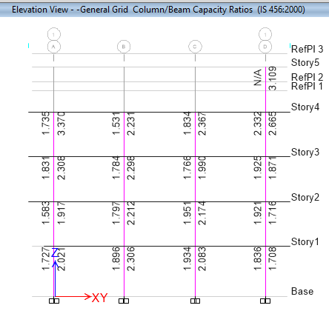

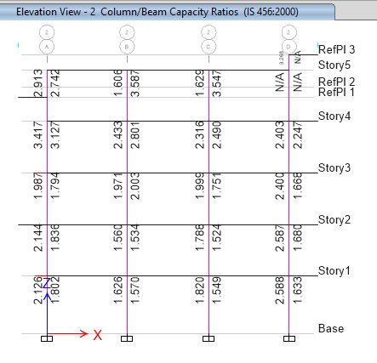
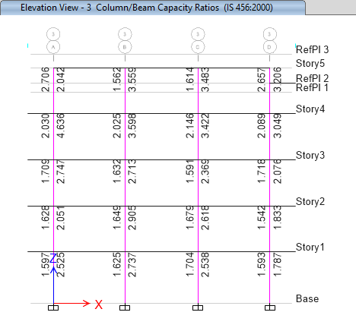

Sample Design of Slab
Design Data
 | f_{ck} |  | = | 20 |  | N/mm²
 | f_{y} |  | = | 500 |  | N/mm²
 | Dimensions of the slab (c/c distance bet^{n} supports),
 | Length of short span, l_{x} |  |  |  |  |  |  |  |  |  |  |  |  |  | = | 3.810 |  | m
 | Length of long span, l_{y} |  |  |  |  |  |  |  |  |  |  |  |  |  | = | 4.260 |  | m |  |  |  |  |  |  |  |  |  |  |  |  | 30.48
 | Width of the supporting beam, |  |  |  |  |  |  |  |  |  |  |  |  |  | = | 230 |  | mm
 | Clear cover to main reinforcement |  |  |  |  |  |  |  |  |  |  |  |  |  | = | 15 |  | mm
 | Assume dia. of reinforcement steel |  |  |  |  |  |  |  |  |  |  |  |  |  | = | 8 |  | mm
Calculations
 | Assume the thickness of slab as |  |  |  |  |  |  |  |  |  |  |  | 125 |  |  | mm ;
 | Effective depth, d_{eff} |  |  |  |  |  |  |  |  |  |  | = | 106 |  |  | mm
 | Effective span, |  |  |  |  |  |  |  | l_{x} | = | 3.81 m (or) 3.686 m whichever is less; |  |  |  |  |  |  |  |  |  |  |  |  |  |  |  | = | 3.686 |  |  | m
 |  |  |  |  |  |  |  |  | l_{y} | = | 4.26 m (or) 4.136 m whichever is less; |  |  |  |  |  |  |  |  |  |  |  |  |  |  |  | = | 4.136 |  |  | m
 | (l_{y} / l_{x}) |  |  | = | 1.12 |  | < | 2 ; | Here, (l_{y} / l_{x}) is less than 2
 | Hence design the slab as two way slab
Load Calculations
 | Dead Load of slab |  |  |  |  |  |  | = | 0.125 x 25 |  |  |  |  | = | 3.13 |  | KN/m²
 | Finishes load on slab |  |  |  |  |  |  |  |  |  |  |  |  | = | 1.25 |  | KN/m²
 | Total Dead load acting on the slab |  |  |  |  |  |  |  |  |  |  |  |  | = | 4.38 |  | KN/m²
 | Live Load on slab |  |  |  |  |  |  |  |  |  |  |  |  | = | 2.0 |  | KN/m²
 | Factored Design Load, W |  |  |  |  |  |  |  |  |  |  |  |  | = | 9.57 |  | KN/m²
Support Condition |  |  |  |  |  |  |  | (Type of panel according to support condition)
 | Two Short Edges Discontinuous |  |  |  |  |  |  |  |  |  |  |  |  |  |  |  |  |  |  |  |  |  | For this support condition,
 | Short span coefficient for (l_{y} / l_{x}) = |  |  |  |  |  |  |  |  |  |  |  |  | 1.12, |  |  |  |  |  | Long span coefficient,
 | For negative moment, |  |  |  |  |  |  |  |  |  | a_{x} | = | 0.050 |  |  |  |  |  |  | For negative moment, |  |  |  |  |  |  |  |  |  | a_{y} | = | 0
 | For positive moment, |  |  |  |  |  |  |  |  |  | a_{x} | = | 0.038 |  |  |  |  |  |  | For positive moment, |  |  |  |  |  |  |  |  |  | a_{y} | = | 0.035
Moment Calculation
 | Max. BM per unit width, |  |  |  |  |  |  |  |  | M_{x} |  | = | a_{x} w l_{x}² |  |  |  | & |  | M_{y} |  | = | a_{y} w l_{x}²
 |  |  |  |  |  |  | M_{u} |  |  | M_{u} / bd² |  |  | p_{t} |  |  | A_{st, req} |  |  |  | A_{st , min} |  |  | = | (0.12/100) bD |  |  |  |  |  | = | 150 |  |  | mm²
 |  |  |  |  |  |  | KNm |  |  | N/mm² |  |  | % |  |  | mm²
 | For Short Span, |  |  |  |  |  |  |  |  |  |  |  |  |  |  |  |  |  |  | Reinforcement details
 | At mid span, |  |  |  |  |  | 4.89 |  |  | 0.44 |  |  | 0.1039 |  |  | 110
 | At supports, |  |  |  |  |  | 6.45 |  |  | 0.57 |  |  | 0.1357 |  |  | 144 |  |  |  | Provide |  |  |  | 8 |  | @ |  | 150 |  | mm c/c at midspan &
 | For Long span, |  |  |  |  |  |  |  |  |  |  |  |  |  |  |  |  |  |  |  | supports for short span |  |  |  |  |  |  |  |  | (A_{st} pro. = |  |  |  | 335 |  | mm² )
 | At mid span, |  |  |  |  |  | 4.55 |  |  | 0.47 |  |  | 0.1112 |  |  | 118 |  |  |  | Provide |  |  |  | 8 |  | @ |  | 150 |  | mm c/c at midspan &
 | At supports, |  |  |  |  |  | 4.89 |  |  | 0.51 |  |  | 0.121 |  |  | 128 |  |  |  |  | supports for long span |  |  |  |  |  |  |  |  | (A_{st} pro. = |  |  |  | 335 |  | mm² )
Check for Deflection
 | Percentage of tension reinforcement |  |  |  |  |  |  |  |  |  |  |  |  | = | 0.27 |  |  | %
 | f_{s} | = | 0.58 f_{y} (A_{st req} / A_{st pro}) |  |  |  |  |  |  |  |  |  |  | = | 95
 | Refer Fig. 4 of IS 456,
 | Modification factor |  |  |  |  |  |  |  |  |  |  |  |  | = | 1.1
 | ( l/ d) _{max} = ( l/ d) _{basic} x k_{t} x k_{c} |  |  |  |  |  |  |  |  |  |  |  |  | = | 28.6
 | ( l/ d)_{provided} |  |  |  |  |  |  |  |  |  |  |  |  | = | 35
 |  |  |  |  |  |  |  |  |  |  |  |  |  | < | ( l/ d) max (i.e. = 28.6) |  |  |  |  |  |  |  | OK
 | Hence safe in deflection.
Check for shear
 | Shear force per m strip (W*l_{x}/2), V = |  |  |  |  |  |  |  |  |  |  |  |  |  | 17.638 |  |  | KN/m
 | Shear stress , (V/bd), τ_{v} = |  |  |  |  |  |  |  |  |  | 0.140 |  |  | N/mm²
 | P_{t} = |  | 0.27%
 | Design Shear Strength of Concrete
 | τ_{c} = |  |  |  |  | 0.360 |  |  | N/mm² |  |  |  | Refer Table 19, IS 456
 |  |  |  |  | > τv (i.e. = 0.14) |  |  |  |  |  |  | OK
 | Since τ_{c} > τ_{v,} so safe in shear.

Sample Staircase Design
Design of Staircase
Grade of concrete fck = |  |  | 20 | N/mm² |  |  | Grade of Steel fy= |  |  | 500 |  | N/mm²
Unit Wt. of concrete γc= |  |  | 25 | KN/m³
Unit Wt. of brick γm= |  |  | 19.2 | KN/m³
Live Load LL = |  |  | 3 | KN/m²
Floor Finish FL = |  |  | 1.25 | KN/m²
Reference | Step | Calculation |  |  | Output
 | 1 | Known Data
 |  | Total height between floor H = |  |  |  |  |  |  | 2.868812 |  | m
 |  | Width of Stair B = |  |  |  |  |  |  | 1.143 |  | m
 |  | Width of Landing W = |  |  |  |  |  |  | 1.143 |  | m
 |  | Riser R = |  |  |  |  |  |  | 177.8 |  | mm
 |  | Tread T = |  |  |  |  |  |  | 254 |  | mm
 |  | c/c length of stair L = |  |  |  |  |  |  | 2.844 |  | m
 |  | bearing width w1 = |  |  |  |  |  |  | 300 |  | mm
 |  | bearing width w2 = |  |  |  |  |  |  | 300 |  | mm
 |  | Stair section a = |  |  |  |  |  |  | 1.066813 |  | m
 |  | Stair section b = |  |  |  |  |  |  | 1.777 |  | m
 |  | Stair section c = |  |  |  |  |  |  | 0.000 |  | m
 | 2 | Effective Span
 |  | Considering longest span of the Flight for Design,
 |  | leff=c/c length |  |  |  |  | 2843.819 |  | mm
 | 3 | Effective depth d
 |  | Using deflection control criteria
IS |  | α= | 23
456:2000 |  |  | 1.5
  γ=δ=β=λ=
 |  |  |  | 82.42952
 |  | Assume clear cover = |  |  |  |  | 15 |  | mm
 |  | using bar dia of = |  |  |  |  | 12 |  | mm
 |  | Required depth Dreq = |  |  |  |  | 103.4295 |  | mm
 |  | Provide overall depth D = |  |  |  |  | 125 |  | mm> Dreq
 |  | effective depth d = |  |  |  |  | 104 |  | mm
 | 4 | Load Calculation
 | i) | Load on Landing
 |  | Self weight = γcx volm= |  |  |  |  | 3.125 |  | KN/m² |  | 3.75
 |  | Live load= |  |  |  |  | 3 |  | KN/m² |  | 3
 |  | Floor finish = |  |  |  |  | 1.25 |  | KN/m² |  | 1.28
 |  | Total load on landing W = |  |  |  |  | 7.375 |  | KN/m² |  | 8.03
 |  | Factored load Wu = 1.5xW= |  |  |  |  | 11.0625 |  | KN/m² |  | Wl=
 |  | Load per unit meter = |  |  |  |  | 11.06 |  | KN/m |  | 11.06 |  |  | KN/m
 | ii) | Load on Going
 |  | Self weight = γc*D*(lin/ln)= |  |  |  |  | 3.815 |  | KN/m²
 |  | Self weight of step =γc*R/2= |  |  |  |  | 2.223 |  | KN/m²
 |  | Live Load LL = |  |  |  |  | 3 |  | KN/m²
 |  | Floor finish FF = |  |  |  |  | 1.25 |  | KN/m²
 |  | Total load on going W = |  |  |  |  | 10.28705 |  | KN/m²
 |  | Factored load Wug = |  |  |  |  | 15.43057 |  | KN/m² |  | Wg=
 |  | Load per unit meter = |  |  |  |  | 15.43 |  | KN/m |  | 15.43 |  |  | KN/m
 | 5 | Bending moment Calculation
IS
456:2000
cl.33.2
 |  | Fy =Va+Vb=11.06*1.066+15.43*1.777+11.06*0
 |  | = | 39.22 | KN
 |  | Taking moment about A,
 |  | Vb=(10.49*a²/2+14.89*b*(a+b/2)+10.49*c*(a+b+c/2))/(a+b+c)
 |  | = | 21.067 | KN per meter width
 |  | Va=Fy-Vb= |  | 18.155 |  |  | KN per meter width
 |  | Let point of zero SF occurs at x distance from A.
 |  | = | Va -11.06*xa-15.43x(X-a)
 |  | X= | 1.479 | m from A
 |  | Since maximum bending moment occurs at zero shear,
 |  | BMmax= | Va*X-11.06*a²/2-15.43*(X-a)*(a+(X-a)/2) |  |  |  |  |  |  |  | Mumax
 |  | Mumax | 12.46 | KN-m per meter unit width |  |  |  |  |  |  | 12.46 |  |  | KN-m
 |  | For limiting bending moment
 |  | Mulim=0.138 fck bd²= |  |  |  |  | 29.85216 |  | KN-m per m unit width
  Here,
 |  | so, one-way slab can be designed.
 | 6 | Design for Main Reinforcement
 |  |  |  |  |  |  |  |  | OK
 |  | Adopting 12mm dia. reinforcement.
 |  | Bar dia. | 12 | mm
 |  | Spacing required Sv =
 |  |  | Sv= | 155.7321
 |  | Providing Spacing of 150mm c/c
 |  | Spacing Sv= |  | 150 |  |  | mm
 |  | Hence, |  |  |  |  |  |  | Provide 12mm φ bar
 |  | Provided Ast=1000*ast/Sv |  |  |  |  |  |  | at 150mm C/C
 |  | = | 753.98 | mm²
 |  | Provide 12mm φ bar at 150mm C/C
 | 7 | Check for deflection control criteria
IS |  | α= | 23
456:2000 |  | β= | 1
cl.23.2.2.c |  | For γ,
 |  | Ast %=100Ast/bD= |  | 0.60 |  |  | %
IS
456:2000
Fig 4 |  | = | 279.3258 | N/mm²
 |  | From fig 4 of IS 456:2000,
 |  | γ= | 1.6
 |  | From fig 5 of IS 456:2000,
 |  | δ= | 1
 |  |  | 1
  λ=
 |  |  |  | 77.28 |  |  | mm<dprovided |  |  |  |  |  | Safe
 |  |  |  |  |  |  | OK
 | 8 | Design for distribution Reinforcement
 |  | Ast min. = 0.12%bD= |  |  |  |  | 124.8 |  | mm²
 |  | Bar dia. Provided = |  | 8 |  |  | mm
 |  | Spacing Sv=1000*ast/Ast
 |  |  | 402.77 | mm
 |  | Provide 10mmdia bar @ 150mmc/c
 |  | hence Sv = | 150 | mm
 |  | Ast provided = |  | 201.0619 |  |  | mm²
 |  | Providmm φ bar @150 mm c/c spacing
 | 9 | Check For Shear
IS 456:2000 |  | Max. shear force, τumax= |  |  |  |  | 18.155 |  | KN
Table 20
Table 19
 |  |  | = | 0.14524 |  |  | N/mm²
 |  |  | pt %= | 0.16085 |  |  | %
 |  | Design Shear stress τc = |  |  |  |  | 0.328 |  | N/mm²>τu
 |  |  |  |  |  |  |  |  | Ok
 |  | Maximum Shear stress τvmax = |  |  |  |  | 2.8 |  | N/mm²>τu |  |  |  | Safe
 | 10 | Check for Development Length
IS
456:2000 |  | Ld= | 679.6875 | mm
cl.26.2.1.1
 |  | 1.3*M1/V= | 892.3656 | mm>Ld, hence Lo is not required |  |  |  |  |  |  |  |  | OK

